**Cloudera Search Full Text Search with Solr**

**HDFS Batch Indexer and Search**

**Author: Michelle Zhang**

**Company: Cloudera**

**Date: 10/26/2014**

# Install Cloudera Search Related Components in Cluster

## Install Solr Related Components

After you installed CM, you can use CM “Add a Service” entry to automatically install Solr Related Components.

Base Components: ZooKeeper, HDFS, YARN(MR2 included), HBase

Cloudera Search Need Components: Solr, Flume, Hue

## Start Solr Related Components’ Services

Start Solr related components’ services in sequence with CM:

CM 🡪 Home 🡪 Start Services(Solr, Flume, Hue)

Take CDH 5.2 cluster as an example, and set $HOME=/root/solr

# Create Collection for HDFS Batch Indexer and Search

## Generate Configuration for Collection

Generate the configuration files for the collection:

# solrctl instancedir --generate /root/solr/solr_configs3

## Prepare Schema.xml for collection

Copy sample schema.xml in the conf dir:

# cp /opt/cloudera/parcels/CDH/share/doc/search-1.0.0+cdh5.2.0+0/examples/solr-nrt/collection1/conf/schema.xml /root/solr/solr_configs3/conf

## Upload Instance Directory to ZooKeeper

# solrctl instancedir --create collection3 /root/solr/solr_configs3

## Create New Collection in HDFS

# solrctl collection --create collection3 -s 3

Then you can verify whether the collection is live in Solr Server Web UI.

For example: <http://ec2-54-68-244-213.us-west-2.compute.amazonaws.com:8983/solr/#/>

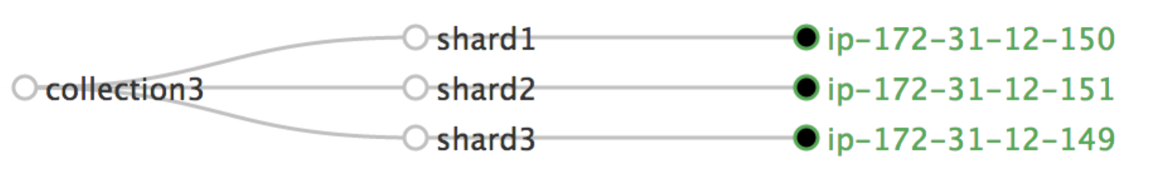

## Prepare Configuration for MapReduce Indexer

# cp -r /root/solr/solr_configs3 /root/solr/collection3

## Prepare Morphline Configuration

This example we use /opt/cloudera/parcels/CDH/share/doc/search-1.0.0+cdh5.2.0+0/examples/solr-nrt/test-morphlines/**tutorialReadAvroContainer.conf**

## Prepare Configuration for MapReduce Indexer

### Create HDFS user index dir

# sudo -u hdfs hadoop fs -mkdir -p /user/root

# sudo -u hdfs hadoop fs -chown root:root /user/root

### Prepare input source in HDFS

# hadoop fs -mkdir -p /user/root/indir

# hadoop fs -copyFromLocal /opt/cloudera/parcels/CDH/share/doc/search-1.0.0+cdh5.2.0+0/examples/test-documents/sample-statuses-*.avro /user/root/indir/

### Clean up output dir for index

# hadoop fs -rm -r -skipTrash /user/root/outdir

# hadoop fs -mkdir /user/root/outdir

# HDFS Batch Online Indexer

## Delete Existing Documents in Solr

#

## Run MapReduceIndexerTool to Index Data with GoLive

# hadoop --config /etc/hadoop/conf.cloudera.yarn jar \

/opt/cloudera/parcels/CDH/lib/solr/contrib/mr/search-mr-1.0.0-cdh5.2.0-job.jar org.apache.solr.hadoop.MapReduceIndexerTool \

-D 'mapred.child.java.opts=-Xmx500m' \

--log4j /opt/cloudera/parcels/CDH/share/doc/search-1.0.0+cdh5.2.0+0/examples/solr-nrt/log4j.properties \

--morphline-file /opt/cloudera/parcels/CDH/share/doc/search-1.0.0+cdh5.2.0+0/examples/solr-nrt/test-morphlines/**tutorialReadAvroContainer.conf** \

--output-dir hdfs://172.31.12.149:8020**/user/root/outdir** \

--verbose **--go-live** --zk-host **$ZKHOST**:2181/solr \

--collection **collection3** hdfs://172.31.12.149:8020**/user/root/indir**

## Check ResourceManager about Indexer Job

There will be a MapReduce job named as “org.apache.solr.hadoop.MapReduceIndexerTool/MorphlineMapper” and “org.apache.solr.hadoop.MapReduceIndexerTool/TreeMergeMapper” running for indexer.

# HDFS Batch Offline Indexer

## Delete Existing Documents in Solr

# solrctl collection --deletedocs collection3

# sudo -u hdfs hadoop fs -rm -r -skipTrash /user/root/outdir

## Run MapReduce Job to Index Data Offline

hadoop --config /etc/hadoop/conf.cloudera.yarn \

jar /opt/cloudera/parcels/CDH/lib/solr/contrib/mr/search-mr-1.0.0-cdh5.2.0-job.jar org.apache.solr.hadoop.MapReduceIndexerTool \

-D 'mapred.child.java.opts=-Xmx500m' \

--log4j /opt/cloudera/parcels/CDH/share/doc/search-1.0.0+cdh5.2.0+0/examples/solr-nrt/log4j.properties \

--morphline-file /opt/cloudera/parcels/CDH/share/doc/search-1.0.0+cdh5.2.0+0/examples/solr-nrt/test-morphlines/tutorialReadAvroContainer.conf \

--output-dir hdfs://172.31.12.149:8020**/user/root/outdir** --verbose \

**--solr-home-dir** **/root/solr/collection3** --shards **3** hdfs://172.31.12.149:8020**/user/root/indir**

## Check ResourceManager about Indexer Job

There will be a MapReduce job named as “org.apache.solr.hadoop.MapReduceIndexerTool/MorphlineMapper” running for indexer.

## Check the Generated Index Files

 Individual shards are written to the results directory as with names of the form part-00000, part-00001, part-00002.

[root@ip-172-31-12-149 solr]# hadoop fs -ls /user/root/outdir/results

Found 4 items

-rw-r--r-- 3 root root 0 2014-10-26 11:43 /user/root/outdir/results/_SUCCESS

drwxr-xr-x - root root 0 2014-10-26 11:43 /user/root/outdir/results/part-00000

drwxr-xr-x - root root 0 2014-10-26 11:43 /user/root/outdir/results/part-00001

drwxr-xr-x - root root 0 2014-10-26 11:43 /user/root/outdir/results/part-00002

[root@ip-172-31-12-149 solr]# hadoop fs -ls /user/root/outdir/results/part-00000/data/index

Found 22 items

-rwxr-xr-x 3 root root 30672 2014-10-26 11:43 /user/root/outdir/results/part-00000/data/index/_0.fdt

-rwxr-xr-x 3 root root 69 2014-10-26 11:43 /user/root/outdir/results/part-00000/data/index/_0.fdx

-rwxr-xr-x 3 root root 2758 2014-10-26 11:43 /user/root/outdir/results/part-00000/data/index/_0.fnm

-rwxr-xr-x 3 root root 4940 2014-10-26 11:43 /user/root/outdir/results/part-00000/data/index/_0.nvd

-rwxr-xr-x 3 root root 112 2014-10-26 11:43 /user/root/outdir/results/part-00000/data/index/_0.nvm

-rwxr-xr-x 3 root root 379 2014-10-26 11:43 /user/root/outdir/results/part-00000/data/index/_0.si

-rwxr-xr-x 3 root root 6795 2014-10-26 11:43 /user/root/outdir/results/part-00000/data/index/_0_Lucene41_0.doc

-rwxr-xr-x 3 root root 3130 2014-10-26 11:43 /user/root/outdir/results/part-00000/data/index/_0_Lucene41_0.pos

-rwxr-xr-x 3 root root 38742 2014-10-26 11:43 /user/root/outdir/results/part-00000/data/index/_0_Lucene41_0.tim

-rwxr-xr-x 3 root root 1825 2014-10-26 11:43 /user/root/outdir/results/part-00000/data/index/_0_Lucene41_0.tip

-rwxr-xr-x 3 root root 30672 2014-10-26 11:43 /user/root/outdir/results/part-00000/data/index/_1.fdt

-rwxr-xr-x 3 root root 69 2014-10-26 11:43 /user/root/outdir/results/part-00000/data/index/_1.fdx

-rwxr-xr-x 3 root root 2758 2014-10-26 11:43 /user/root/outdir/results/part-00000/data/index/_1.fnm

-rwxr-xr-x 3 root root 4940 2014-10-26 11:43 /user/root/outdir/results/part-00000/data/index/_1.nvd

-rwxr-xr-x 3 root root 112 2014-10-26 11:43 /user/root/outdir/results/part-00000/data/index/_1.nvm

-rwxr-xr-x 3 root root 415 2014-10-26 11:43 /user/root/outdir/results/part-00000/data/index/_1.si

-rwxr-xr-x 3 root root 6795 2014-10-26 11:43 /user/root/outdir/results/part-00000/data/index/_1_Lucene41_0.doc

-rwxr-xr-x 3 root root 3130 2014-10-26 11:43 /user/root/outdir/results/part-00000/data/index/_1_Lucene41_0.pos

-rwxr-xr-x 3 root root 38742 2014-10-26 11:43 /user/root/outdir/results/part-00000/data/index/_1_Lucene41_0.tim

-rwxr-xr-x 3 root root 1825 2014-10-26 11:43 /user/root/outdir/results/part-00000/data/index/_1_Lucene41_0.tip

-rwxr-xr-x 3 root root 98 2014-10-26 11:43 /user/root/outdir/results/part-00000/data/index/segments_2

-rwxr-xr-x 3 root root 98 2014-10-26 11:43 /user/root/outdir/results/part-00000/data/index/segments_3

## List Collection Folders

List folders used as part of the path to each index in the SolrCloud cluster.

[root@ip-172-31-12-149 ~]# hadoop fs -ls /solr/collection3

Found 3 items

drwxr-xr-x - solr solr 0 2014-10-26 11:02 /solr/collection3/core_node1

drwxr-xr-x - solr solr 0 2014-10-26 11:02 /solr/collection3/core_node2

drwxr-xr-x - solr solr 0 2014-10-26 11:02 /solr/collection3/core_node3

## Stop Solr Service and Move Index Shards

### Stop Solr service by CM

### Delete old files

# sudo -u solr hadoop fs -rm -r –skipTrash /solr/collection3/core_node1/data/index

# sudo -u solr hadoop fs -rm -r -skipTrash /solr/collection3/core_node2/data/index

# sudo -u solr hadoop fs -rm -r -skipTrash /solr/collection3/core_node3/data/index

### Ensure correct ownership of required directories

# sudo -u hdfs hadoop fs -chown -R solr /user/root/outdir/results

### Move index shards into place

# sudo -u solr hadoop fs -mv /user/root/outdir/results/part-00000/data/index /solr/collection3/core_node1/data

# sudo -u solr hadoop fs -mv /user/root/outdir/results/part-00001/data/index /solr/collection3/core_node2/data

# sudo -u solr hadoop fs -mv /user/root/outdir/results/part-00002/data/index /solr/collection3/core_node3/data

## Start Solr Service

Start Solr Service by CM.

# Cloudera Search Result in Solr and Hue UI

## Check Solr Queries

You can check Solr Server Web UI to query the results

<http://ec2-54-68-244-213.us-west-2.compute.amazonaws.com:8983/solr/#/collection3_shard3_replica1/query>

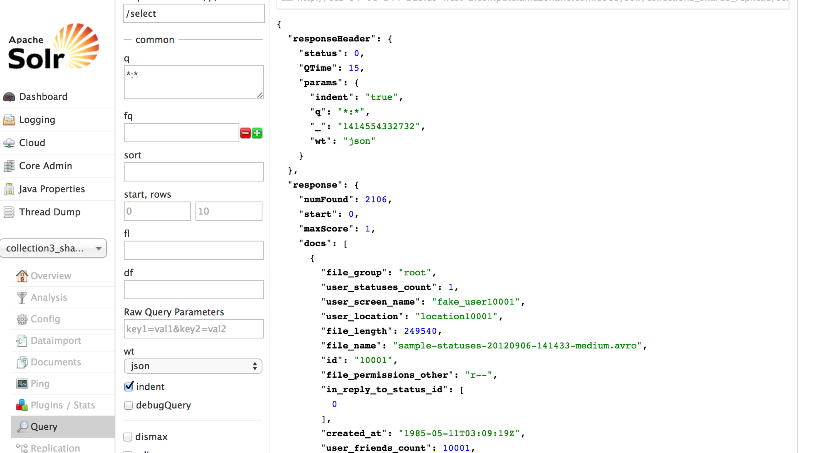

## Hue → Search

Hue 🡪 Search, then you can see all the available collections live in Cloudera Search.

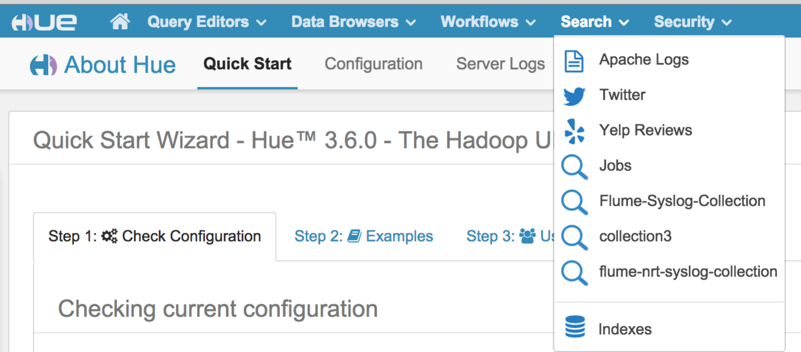

## Hue → Search 🡪 Indexes

Hue 🡪 Search 🡪 Indexes, you can see all the available indexes in Cloudera Search.

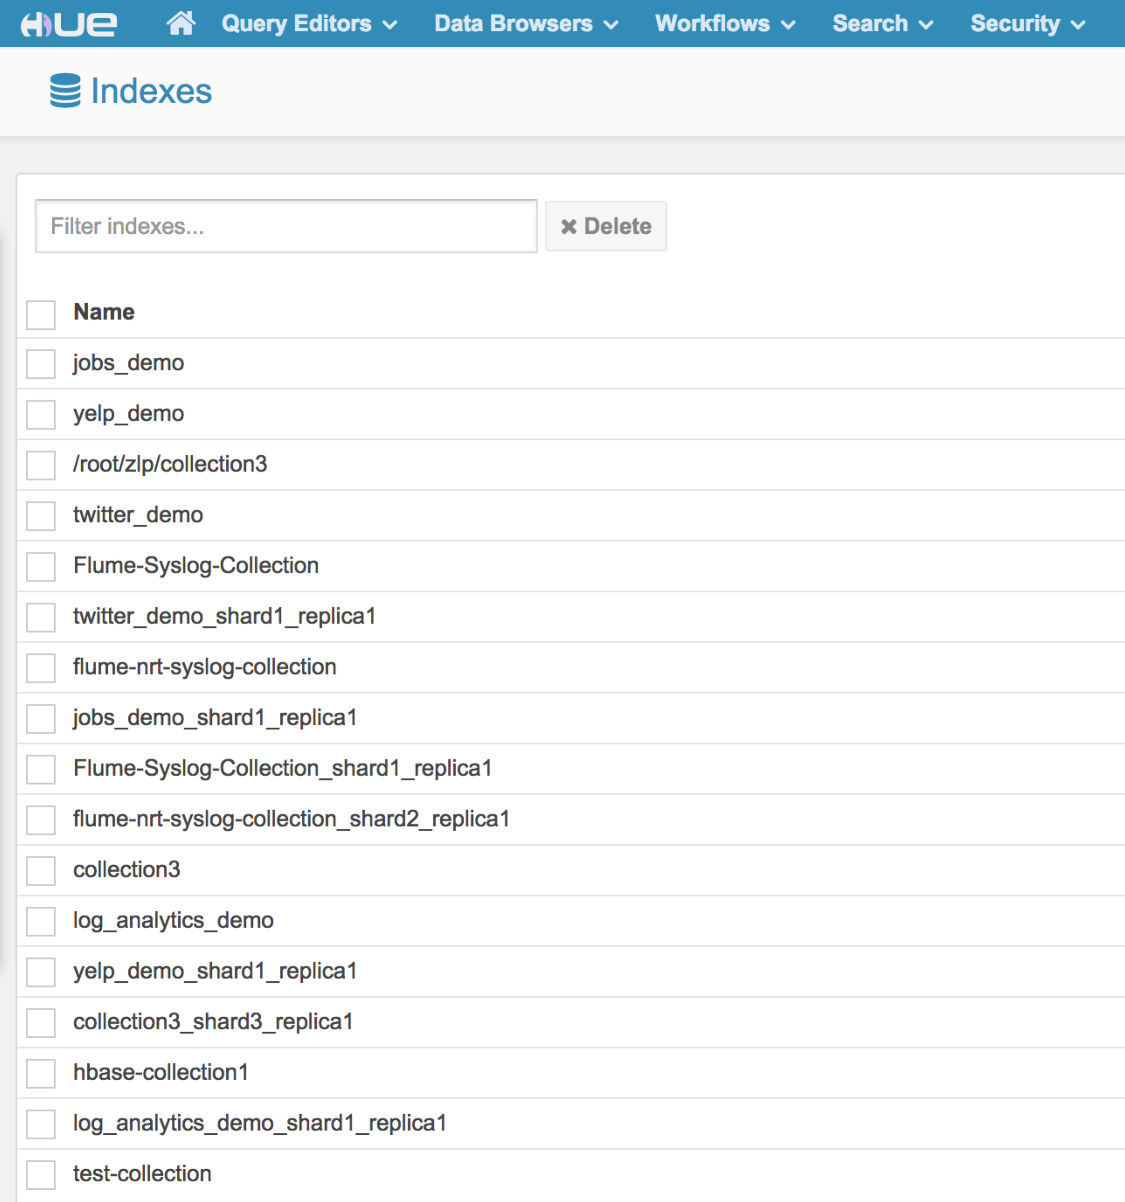

## Hue → Search 🡪 Indexes 🡪Collection3

Hue 🡪 Search 🡪 Indexes🡪Collection3, you can see all the available indexes definition for collection3.

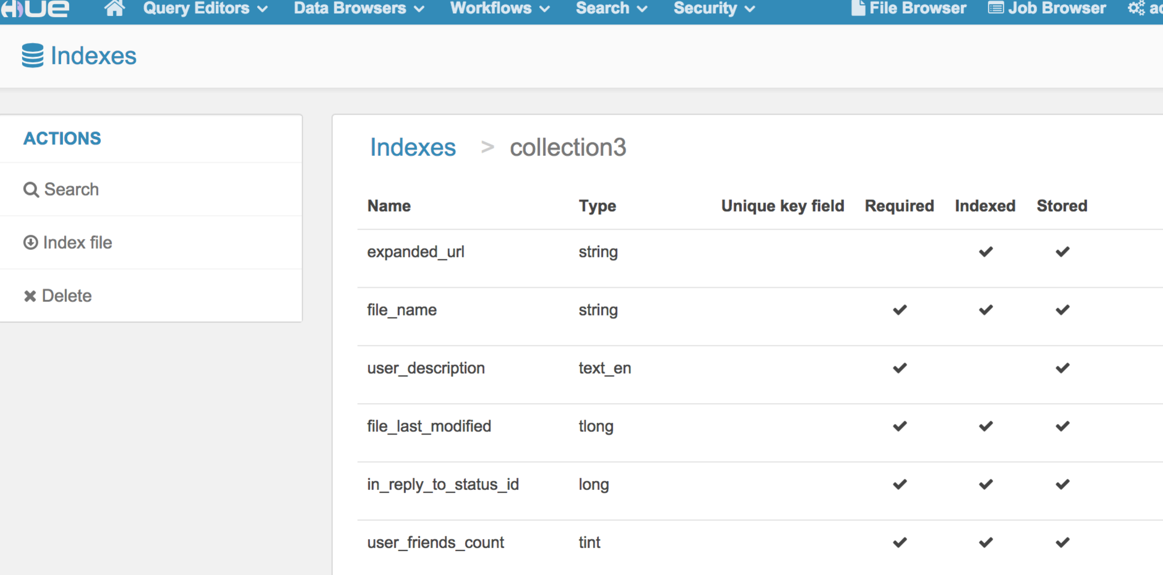

## Hue → Search 🡪 Indexes 🡪Collection3 🡪 Search

Hue 🡪 Search 🡪 Indexes🡪Collection3 🡪 Search, you can see the Search Bar and, index Fields, and results for collection3.

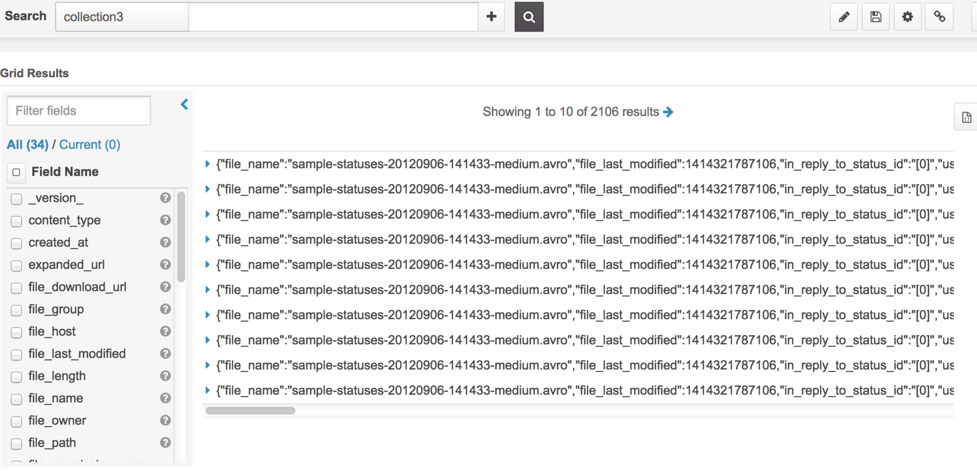

## Search Keyword

Hue 🡪 Search 🡪 Indexes🡪Collection3 🡪 Search, Search keyword in Search Bar to run full text search, for example: “tweet”.

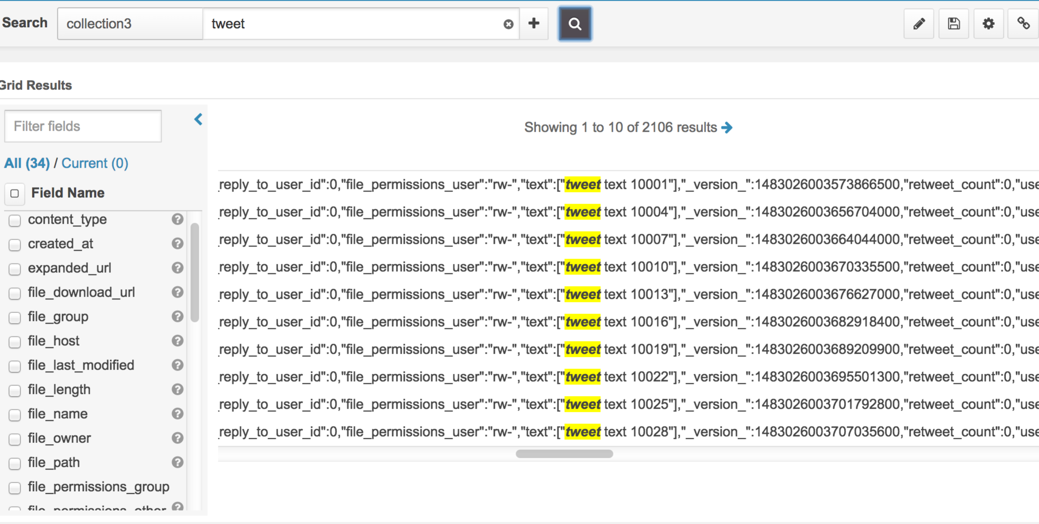

# Cloudera Search Result in Solr and Hue UI

## Twitter Demo Result

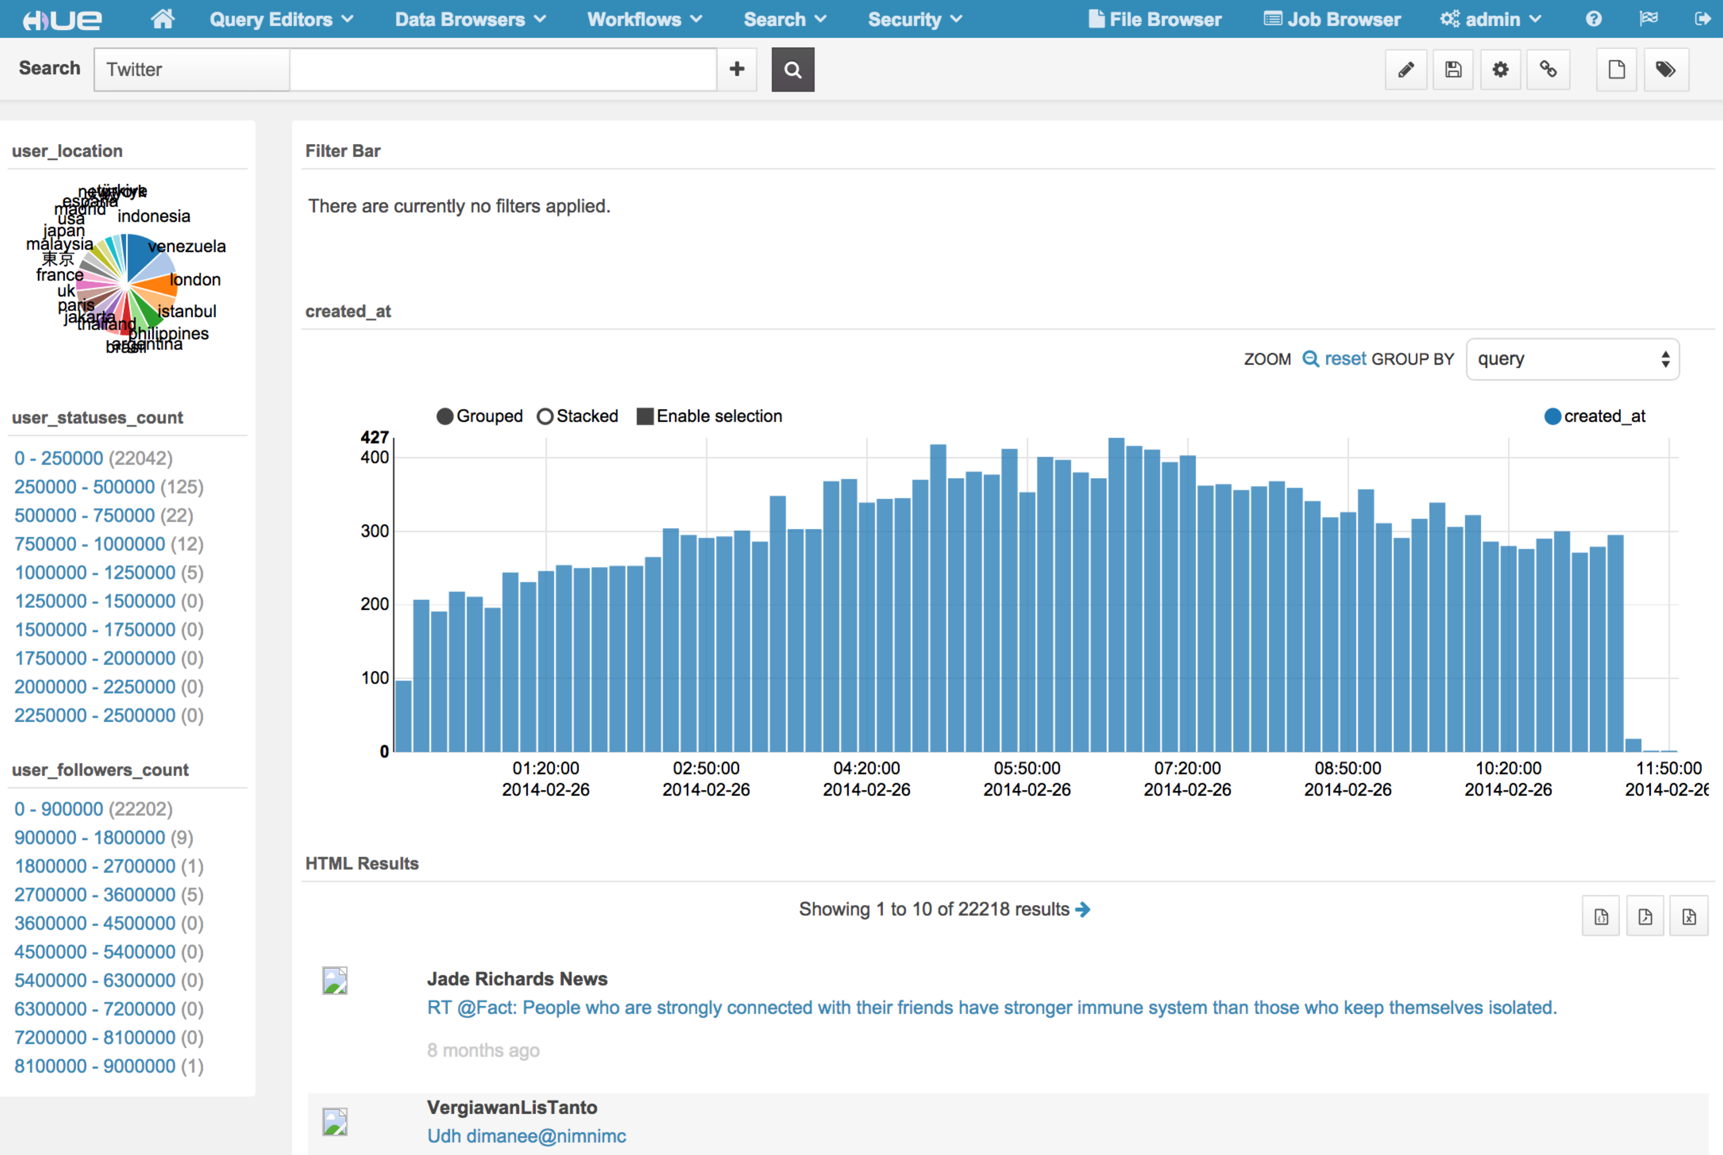

Search “Friends”:

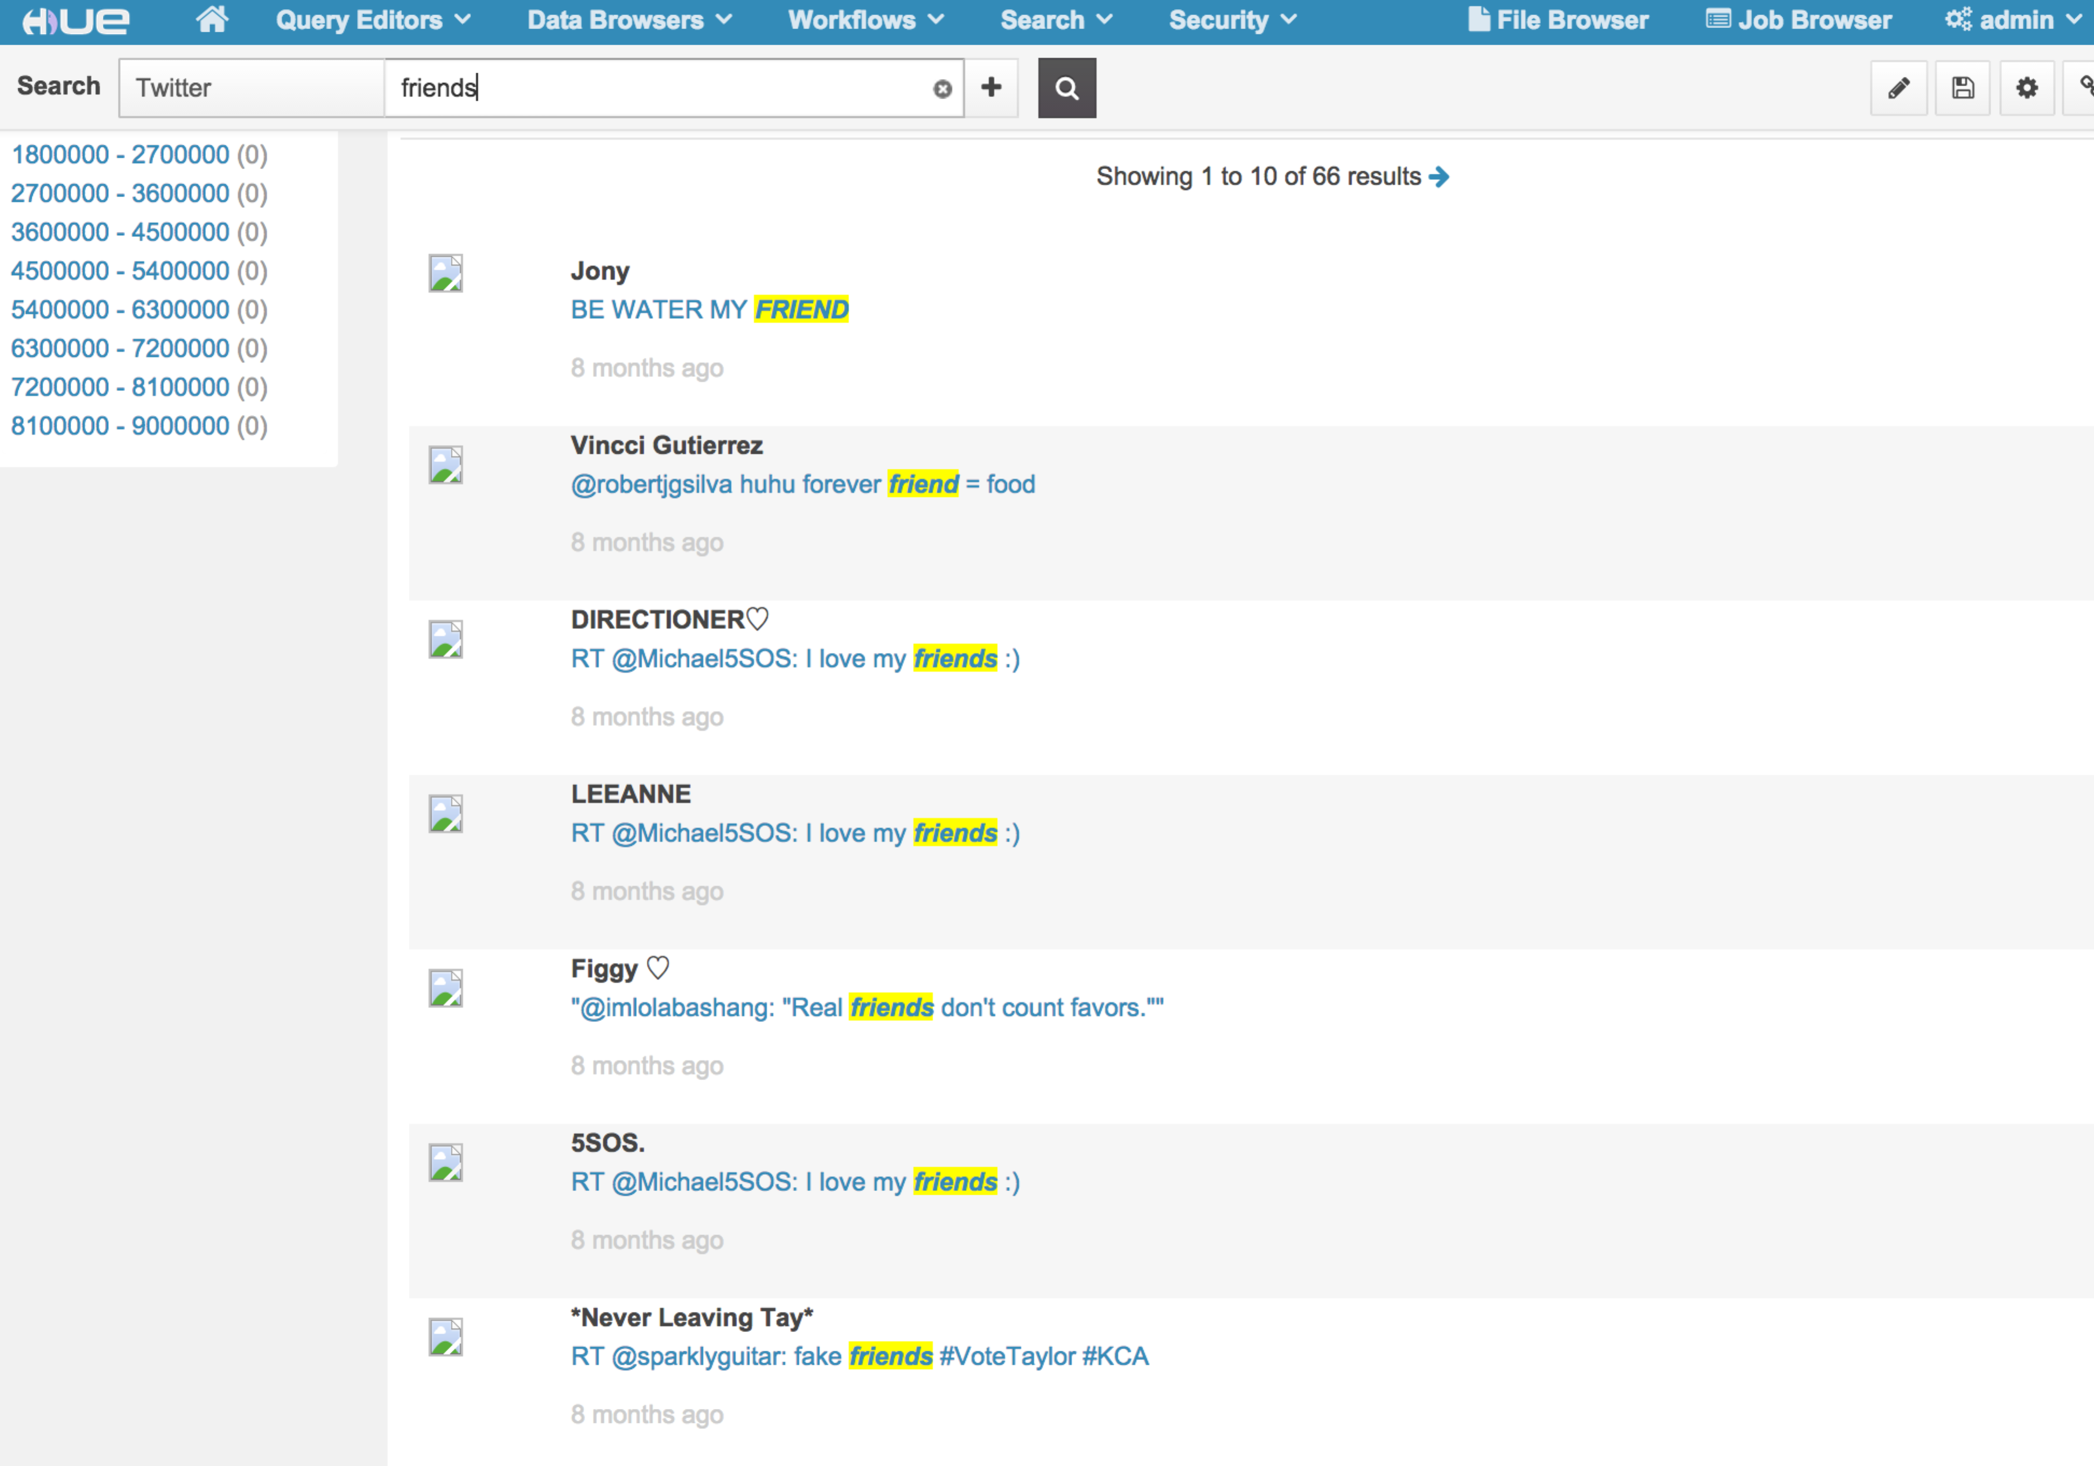

## Yelp Review Demo Result

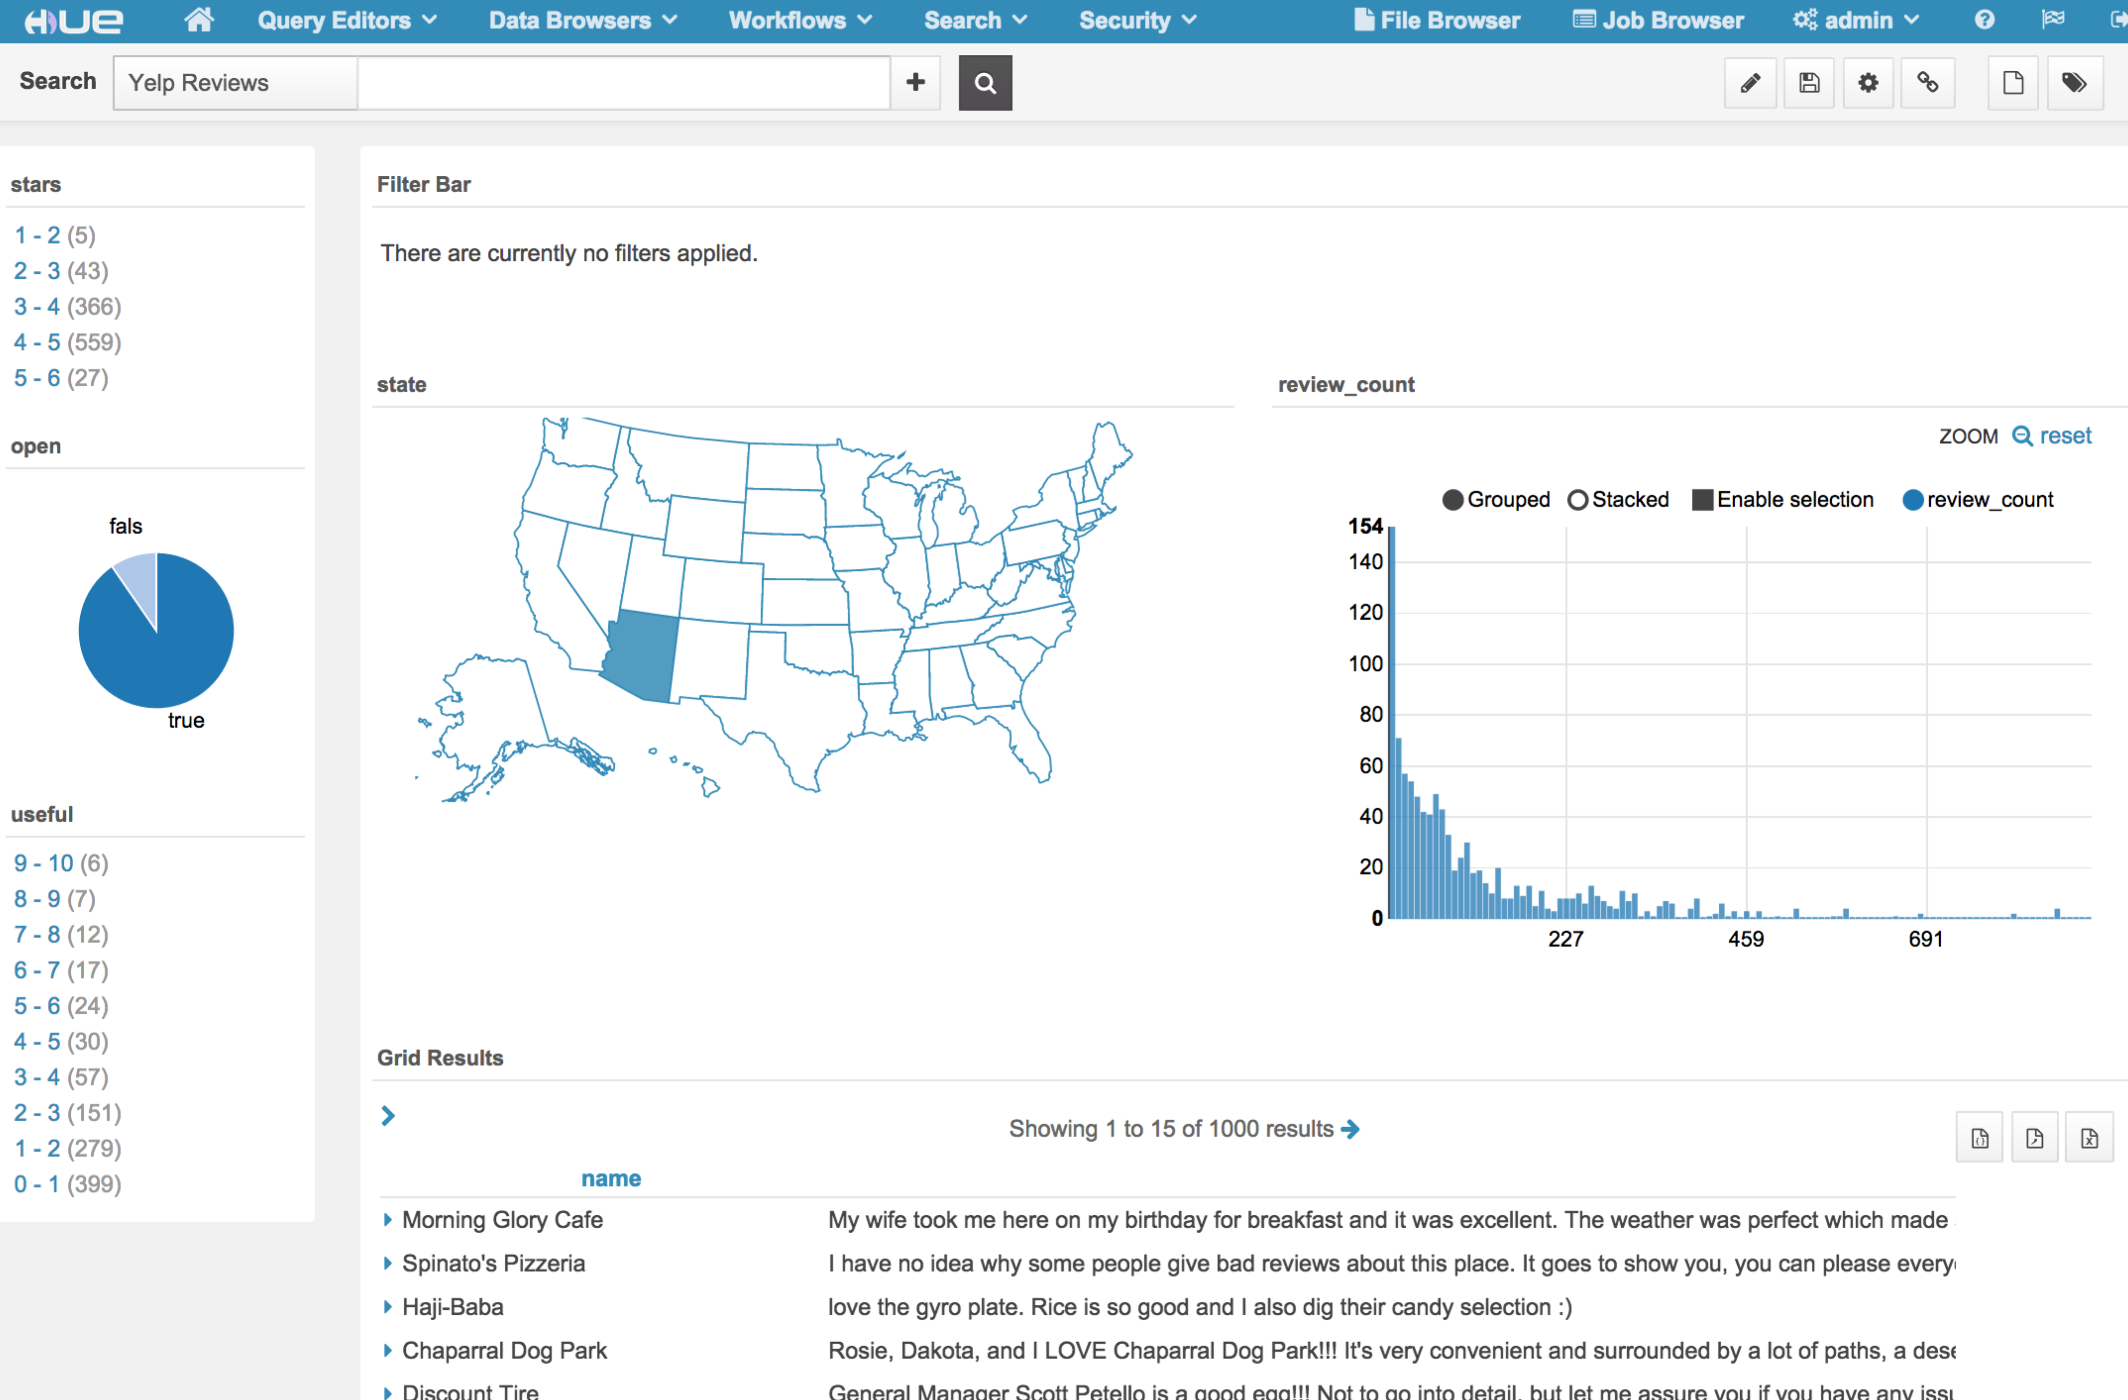

Search “windows”:

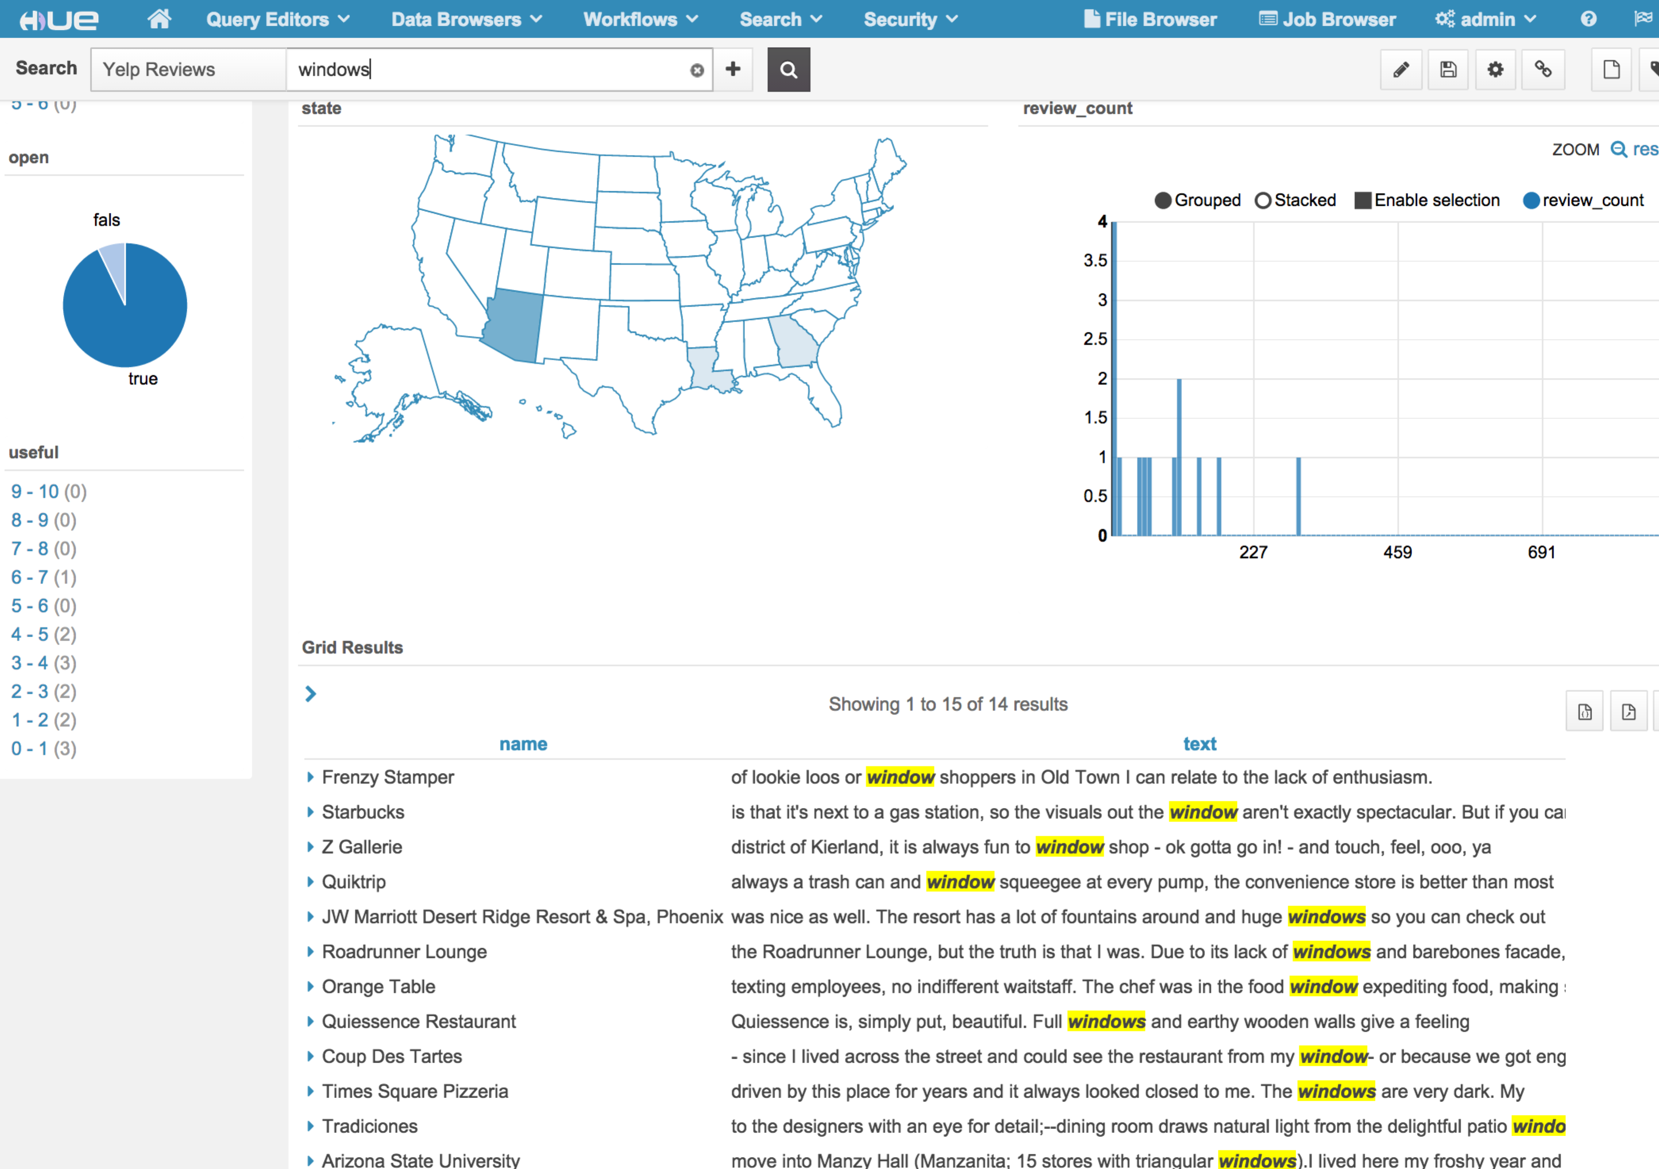

## Job Demo Result

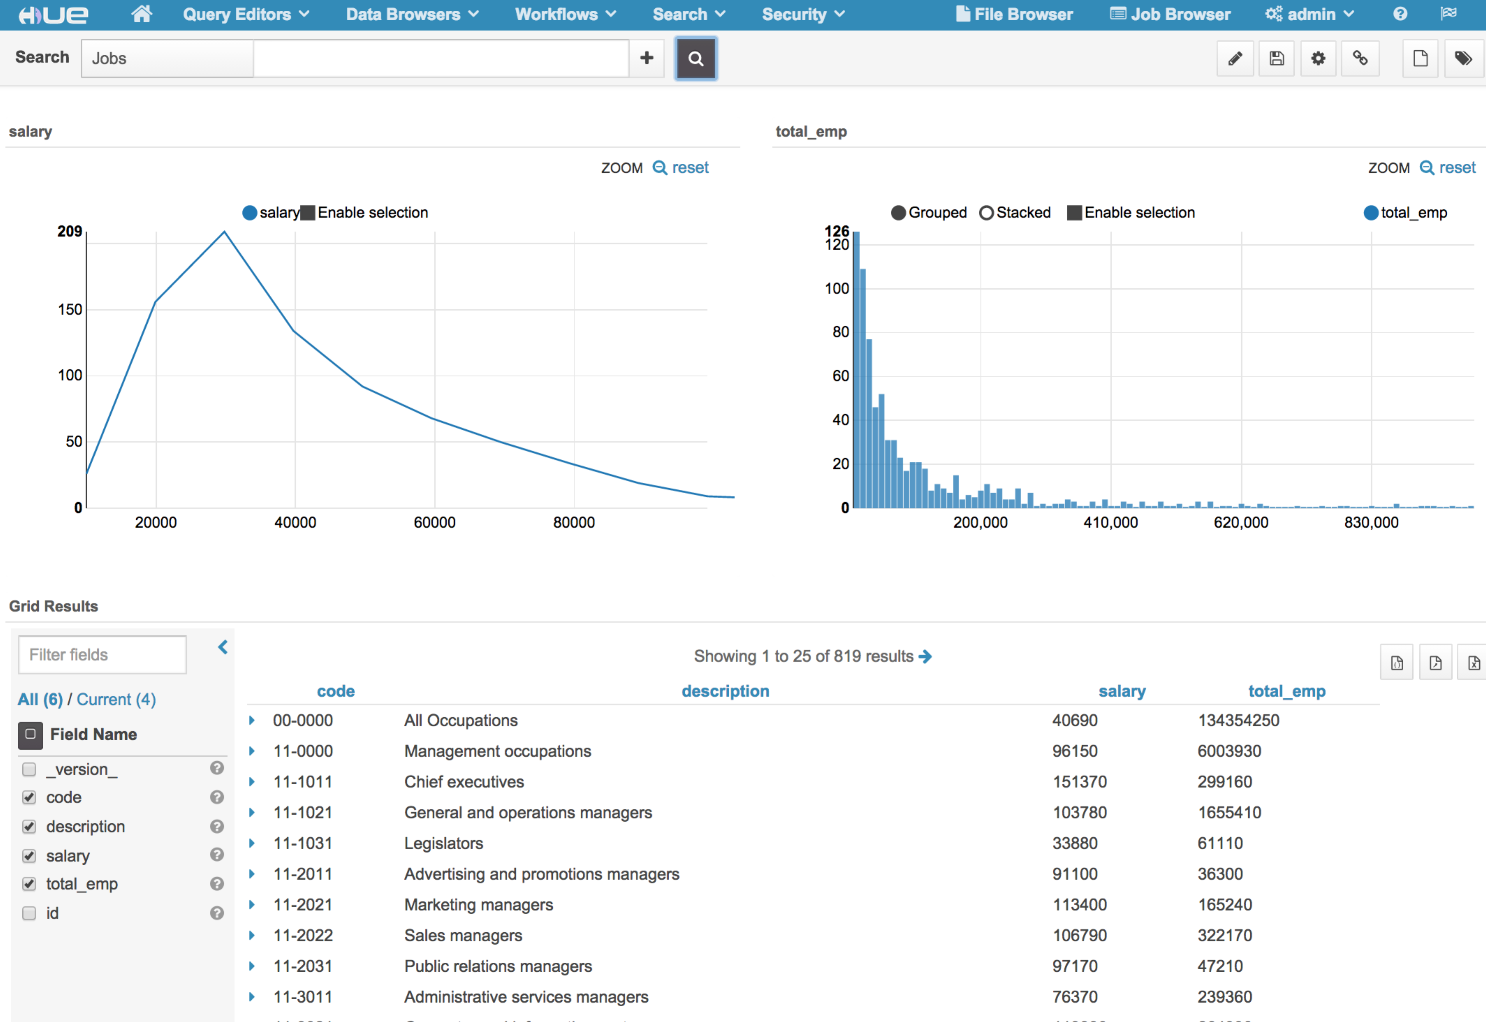

Search “managers”:

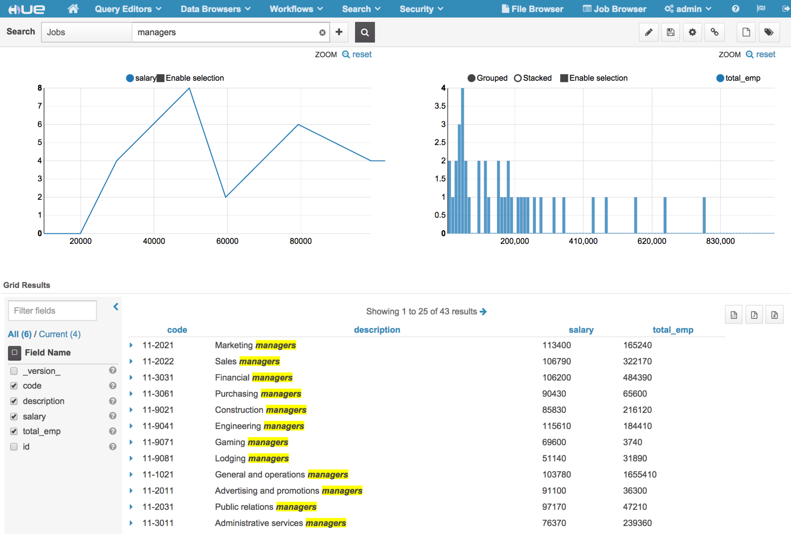

## Apache Log Demo

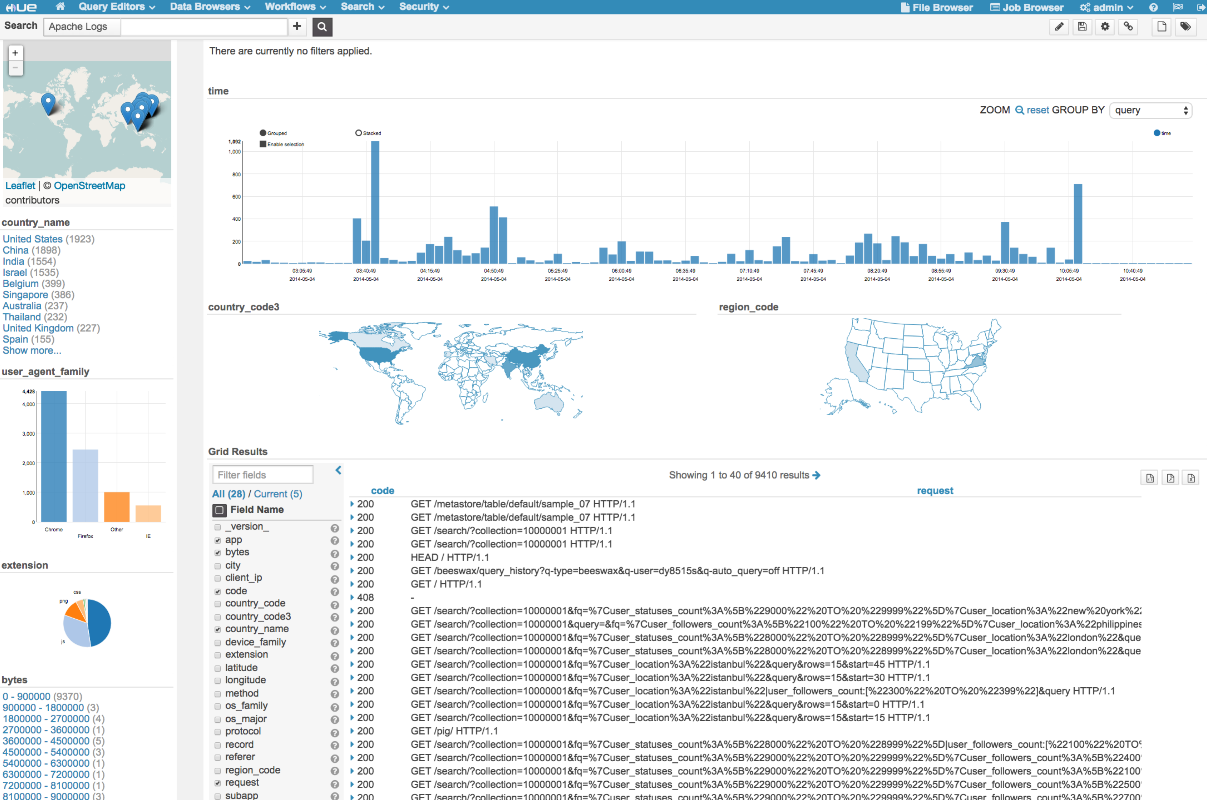

Search “metastore”:

